**IPL SEASON Analysis**

Dataset Link 👇👇👇👇👇👇👇👇👇👇👇👇👇👇👇👇👇👇👇👇

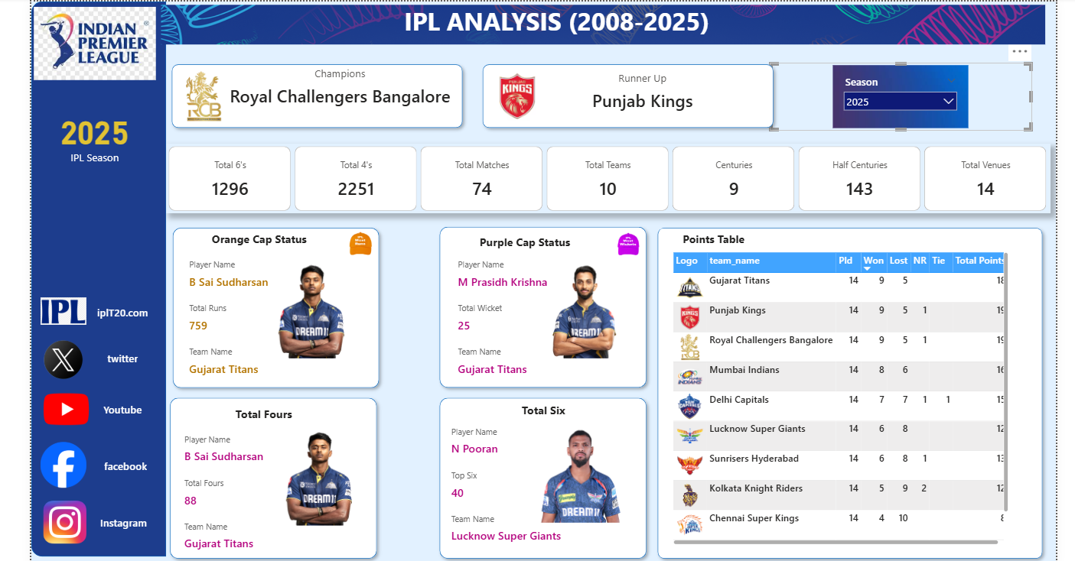https://drive.google.com/drive/folders/1OS0t10CvR_SgLB-DpqoLHCOr66dIIxO7